FINDING JOURNAL ARTICLES - HANDS-ON EXERCISE
Search Techniques
INFORMATION RESOURCE | BOOLEAN OPERATORS | PHRASE | TRUNCATION
EBSCOhost | and  or  not | “ “ | *
ScienceDirect  (Click button on Science Direct’s Home Page) | and  or  and not | “ “ | *
Sabinet Online  (Click Advanced Search on Sabinet’s Home Page). | and  or  not | Type w between keywords | ? (open-ended truncation)  + (plurals ending with s or es)
Google Scholar  http://scholar.google.com | and  or  (can also use | for or Example: aids|hiv)  - Example:  virus -cmputer | “ “ | No truncation  Use |  Example: bank|banks|banking|bankruptcy

- EBSCOhost
  - Go to the library website: www.nmmu.ac.za/library or the library web site via student/staff portal
  - Select Databases on Web.
  - Scroll down to the database EBSCOHost and click on on-campus.
  - Always select the following 3 databases on EBSCOHost, irrespective of your topic, as they are multi-disciplinary:
- Acdemic Search Complete,
- E-Journals and
- MasterFILE Premier
Add other databases according to your topic. For this example add GreenFILE as it matches the topic: Global warming.
  - Click at the top or bottom of page.
1.6 Do the following search on EBSCOHost:
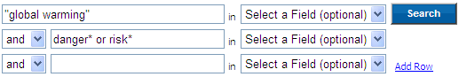
1.7. Add 3 relevant full text articles to your folder by clicking on the button.
1.8 Click on the button at the top of the screen.
1.9 Once on the Folder Page, select all the articles again by ticking the boxes next to articles
1.10 E-mail these articles to yourself by clicking on the e-mail button.

